CSC112/256 Fall 2026 Midterm Exam
Student Name: ID： _
Total Points

Note: This exam paper should be kept confidential and any dissemination violates copyright.
Q1 | Q2 | Q3 | Q4 | Q5
/20 | /15 | /15 | /30 | /20

Q1 Multiple-choice questions: enter your answer keys here:
1 | 2 | 3 | 4 | 5 | 6 | 7 | 8 | 9 | 10
11 | 12 | 13 | 14 | 15 | 16 | 17 | 18 | 19 | 20

Q1. Multiple-choice. (20 pts)
For the following multiple-choice questions, each question has exactly one correct answer key. If multiple choices are correct, choose the option “All of the above”. Fill in the answer keys in the table above. (Answer keys written in the question area will not be counted.)

1. Which of these is an example of virtualization provided by an OS?
A) A large, private virtual address-space abstraction
B) Direct access to hardware by applications
C) Physical resource duplication
D) Hardware error correction
2. What does a process consist of in an operating system?
A) Only memory and CPU time allocation
B) Only threads of control
C) Address space, threads, and additional system state (e.g., open files, sockets)
D) Only compiled code and libraries
3. Which of the following is NOT considered a core abstraction provided by an OS?
A) Physical hardware duplication for processes
B) Sockets for networks
C) Files for storage devices
D) Threads for processors
4. What does "protection" in an operating system ensure?
A) That users have unrestricted access to hardware resources
B) That processes cannot interfere with each other or the OS itself
C) That all applications run in kernel mode for efficiency
D) That only one application can run at a time on the machine
5. Which of the following is NOT part of a process's memory layout?
A) Code
B) Heap
C) Cache
D) Stack
6. What is the difference between wait() and waitpid()?
A) waitpid() suspends processes, while wait() terminates them.
B) waitpid() allows specifying which child process to wait for, while wait() does not.
C) Both are identical in functionality.
D) wait() waits for all processes, while waitpid() waits only for threads.
7. In user-level threading, what manages thread scheduling?
A) Hardware interrupts
B) System calls
C) User-level thread library
D) Operating system kernel
8. What does the term "process tree" refer to?
A) A hierarchical representation of all running threads within an OS
B) A binary tree used for scheduling algorithms
C) A list of all processes sorted by their priority levels
D) A structure showing parent-child relationships among processes
9. In the Readers/Writers problem, why might writers starve?
A) New readers continuously acquire the lock before writers
B) Writers have higher priority
C) Semaphores are initialized incorrectly
D) Mutex locks are not used
10. What does sem_init(&sem, 0, 3) indicate about the semaphore?
A) Uninitialized semaphore
B) Binary semaphore for mutual exclusion
C) Priority-based semaphore
D) Counting semaphore allowing 3 concurrent accesses
11. What happens when sem_wait() is called on a semaphore with value 0?
A) Blocks until sem_post() is called
B) Causes a segmentation fault
C) Increments the value to +1
D) Returns immediately
12. Which condition variable operation wakes all waiting threads?
A) pthread_cond_init()
B) pthread_cond_wait()
C) pthread_cond_broadcast()
D) pthread_cond_signal()
13. In a Resource-Allocation Graph (RAG), a deadlock is certain if:
A) There is no cycle
B) There is a cycle and each resource has multiple instances
C) There is a cycle and all resources have single instances
D) A thread requests two resources simultaneously
14. In a Resource Allocation Graph (RAG) with a cycle and multi-instance resources:
A) Starvation must occur
B) Deadlock is possible but not certain
C) Deadlock is certain
D) Deadlock is impossible
15. Starvation differs from deadlock because:
A) Starvation cannot occur in priority-based systems
B) Deadlock involves circular waiting
C) Starvation involves circular waiting
D) Starvation always prevents every process from progressing
16. Which is true about the Banker’s algorithm?
A) It does not require processes to declare maximum resource needs
B) It uses spooling for printers
C) It requires processes to declare maximum resource needs
D) It prioritizes low-resource threads
17. What characterizes a CPU-bound process?
A) Frequent I/O operations with short CPU bursts
B) Equal distribution of CPU and I/O operations
C) Prioritizes user interaction
D) Long CPU bursts with infrequent I/O waits
18. Which metric is calculated as CompletionTime - ArrivalTime?
A) Throughput
B) Waiting time
C) CPU utilization
D) Response time
19. What is the primary advantage of Shortest Remaining Time First (SRTF)?
A) Maximizes CPU utilization
B) Minimizes average response time
C) Avoids starvation
D) Ensures fairness among all jobs
20. Which scenario benefits most from SRTF?
A) Real-time system
B) Embedded system with fixed tasks
C) Batch processing system
D) Interactive system with mixed job lengths
Q2 Processes and Threads (15 pts)
For these questions, assume there is no error, i.e., the return value of fork() is never negative. Assume the parent and child may be scheduled in any order unless an explicit synchronization operation imposes an ordering constraint. Assume stdout is connected to a terminal and each newline flushes the displayed line before any relevant fork() or execv() operation. (You need to provide the possible outputs and explain why. You do not need to draw the figures to show the parent child relationships.)
(a) (3 pts) What is the output of this program? If there may be multiple possible outputs, list ALL possible outputs, and explain why. Assume the virtual memory address of variable a in the initial process, &a = 0x7ffc3a10.
1 int main(void) {
2 int a = 7;
3 pid_t fork_ret = fork();
4 if (fork_ret > 0) {
5 a += 3;
6 fprintf(stdout, "Parent: int a is %d at %p\n", a, &a);
7 } else if (fork_ret == 0) {
8 a -= 2;
9 fprintf(stdout, "Child: int a is %d at %p\n", a, &a);
10 } else {
11 printf("Fork error");
12 }
13 }
ANS:
(b) (3 pts) How many new processes (not including the original process) are created when the following program is run, and how many lines of "hello" are printed? Explain.
1 int main(void) {
2 for (int i = 0; i < 4; i++)
3 fork();
4 printf("hello\n");
5 return 0;
6 }
ANS:
(c) (3 pts) What is the output of this program? If there may be multiple possible outputs, list ALL possible outputs, and explain why.
1 int main(void) {
2 char** argv = (char**) malloc(3 * sizeof(char*));
3 argv[0] = "/bin/ls";
4 argv[1] = ".";
5 argv[2] = NULL;
6 for (int i = 0; i < 8; i++) {
7 printf("%d\n", i);
8 if (i == 5) {
9 execv("/bin/ls", argv);
10 }
11 }
12 return 0;
13 }
ANS:
(d) (3 pts) What is the output of this program? If there may be multiple possible outputs, list ALL possible outputs, and explain why.
1 int main(void) {
2 char** argv = (char**) malloc(3 * sizeof(char*));
3 argv[0] = "/bin/ls";
4 argv[1] = ".";
5 argv[2] = NULL;
6 for (int i = 0; i < 8; i++) {
7 printf("%d\n", i);
8 if (i == 5) {
9 if (fork() == 0)
10 execv("/bin/ls", argv);
11 }
12 }
13 return 0;
14 }
ANS:
(e) (3 pts) What is the output of this program? If there may be multiple possible outputs, list ALL possible outputs, and explain why.
1 int main(void) {
2 char** argv = (char**) malloc(3 * sizeof(char*));
3 argv[0] = "/bin/ls";
4 argv[1] = ".";
5 argv[2] = NULL;
6 for (int i = 0; i < 8; i++) {
7 printf("%d\n", i);
8 if (i == 5) {
9 pid_t ret = fork();
10 if (ret == 0)
11 execv("/bin/ls", argv);
12 if (ret > 0)
13 wait(NULL);
14 }
15 }
16 return 0;
17 }
ANS:
Q3 Synchronization (15 pts)
(a) (4 pts) Consider the following concurrent program, where three threads access a shared variable x within critical sections protected by mutex locks. What are the possible final values of x after all threads finish execution? Explain why.
pthread_mutex_t mutex = PTHREAD_MUTEX_INITIALIZER; //global mutex
int x = 4; //x is a global shared variable
//Thread T1:
pthread_mutex_lock(&mutex);
x = x + 4;
pthread_mutex_unlock(&mutex);
//Thread T2:
pthread_mutex_lock(&mutex);
x = x - 4;
pthread_mutex_unlock(&mutex);
//Thread T3:
pthread_mutex_lock(&mutex);
x = x / 2;
pthread_mutex_unlock(&mutex);
ANS:
(b) (4 pts) Consider the following concurrent program, where three threads access a shared variable x without mutex locks. What are the possible final values of x after all threads finish execution? Explain why.
int x = 4; //x is a global shared variable
//Thread T1:
x = x + 4;
//Thread T2:
x = x - 4;
//Thread T3:
x = x / 2;
ANS:
(c) (3 pts) A counting semaphore S is initialized to 8. Then 13 sem_wait(&S) (P) operations and 9 sem_post(&S) (V) operations are performed on S by different threads, in some order. What is the value of S after all of these operations have completed? Explain.
ANS:
(d) (4 pts) A shared variable x is initialized to 10. Four threads W, X, Y and Z run concurrently. W and X each execute x = x + 2, while Y and Z each execute x = x - 3. Each thread calls sem_wait(&s) before reading x and sem_post(&s) after writing x back, where s is a counting semaphore initialized to 2. Each update x = x ± k is performed as: load x into a register, update the register, store it back to x, and a thread can be preempted between any two of these steps. What are the maximum and the minimum possible final values of x after all four threads finish? Explain.
sem_t s; sem_init(&s, 0, 2); //counting semaphore, initial value 2
int x = 10; //x is a global shared variable
//Threads W and X:
sem_wait(&s);
x = x + 2;
sem_post(&s);
//Threads Y and Z:
sem_wait(&s);
x = x - 3;
sem_post(&s);
ANS:
Q4 Deadlocks (30 pts) Consider the following Resource Allocation Graphs (a) and (b), each with 4 threads and 2 resource types. The number of small dots in the box of resource Rj indicates the number of instances of Rj. An arrow from thread Ti to resource Rj indicates that Ti requests 1 instance of Rj; an arrow from Rj to Ti indicates that Ti is holding 1 instance of Rj. Assume each thread's maximum claim is what it currently holds plus what it is requesting (Max = Allocation + Request). For each graph, use Banker’s algorithm to determine (1) whether the current state is deadlocked, and (2) whether a safe sequence exists; if one exists, give a safe sequence of thread completions. (You need to give the Max, Allocation, Need matrices, Total and Available vectors, and Available resources after completion of each thread.)
(a) (10 pts) Resource Allocation Graph 1 and corresponding tables.
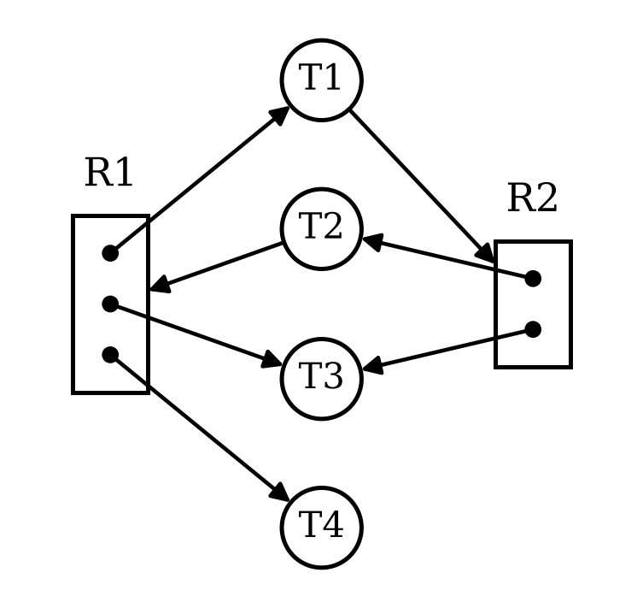
  Max |  |  |  | Allocation |  |  |  | Need
   | R1 | R2 |  |  | R1 | R2 |  |  | R1 | R2
  T1 |  |  |  | T1 |  |  |  | T1
  T2 |  |  |  | T2 |  |  |  | T2
  T3 |  |  |  | T3 |  |  |  | T3
  T4 |  |  |  | T4 |  |  |  | T4
  Total |  |  | Available |  |  | Available
  R1 | R2 |  | R1 | R2 |  |  | R1 | R2
   |  |  |  |  |  | Init

(b) (10 pts) Resource Allocation Graph 2 and corresponding tables.
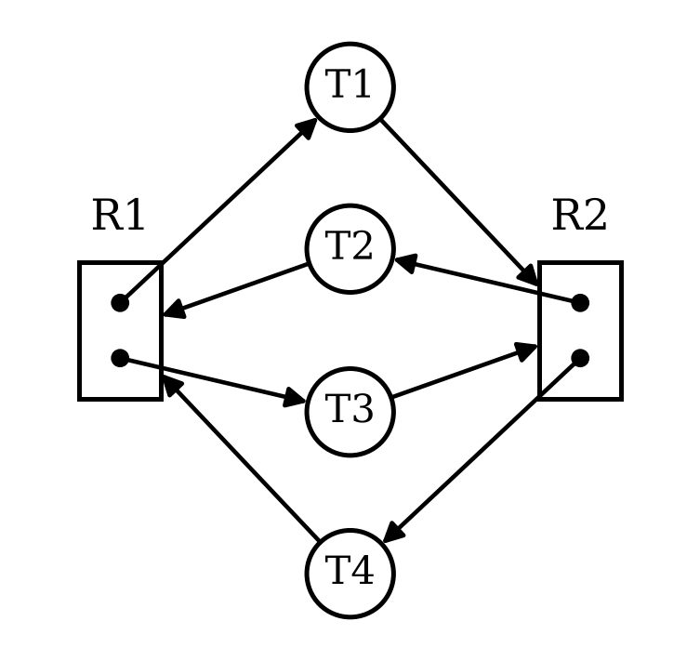
  Max |  |  |  | Allocation |  |  |  | Need
   | R1 | R2 |  |  | R1 | R2 |  |  | R1 | R2
  T1 |  |  |  | T1 |  |  |  | T1
  T2 |  |  |  | T2 |  |  |  | T2
  T3 |  |  |  | T3 |  |  |  | T3
  T4 |  |  |  | T4 |  |  |  | T4
  Total |  |  | Available |  |  | Available
  R1 | R2 |  | R1 | R2 |  |  | R1 | R2
   |  |  |  |  |  | Init
(c) (10 pts) Consider the Dining Lawyers problem. There are 3 lawyers P1 to P3, each with a different number of arms. P1 has 2 arms and needs 2 forks to eat; P2 has 3 arms and needs 3 forks to eat; P3 has 4 arms and needs 4 forks to eat. There is a pile of 6 forks at the center of the table. Each lawyer picks up one fork at a time, and when he gets enough forks, he eats and then puts down all his forks.
(1) (7 pts) Starting from the initial state (no forks held), use Banker’s algorithm to determine whether the system can reach an unsafe or deadlocked state. If yes, show such a state and explain why it is deadlocked. If no, explain why every reachable state is safe. (You need to give the Max, Allocation, Need matrices, Total and Available vectors.)
ANS:
(2) (3 pts) What is the minimum number of forks in the pile that guarantees that the three lawyers can never be deadlocked, no matter in which order they pick up forks? Explain.
ANS:
Q5 Scheduling (20 pts)
(a) (16 pts) Consider the set of 2 processes whose arrival time and CPU/IO burst times are given below. For each scheduling algorithm (FCFS, SJF, SRTF, RR, Fixed-Priority (FP)), draw the Gantt chart by filling in the table with the PID that runs in each time slot, and calculate the response time for each process, and the average response time. Assume that context switch overhead is 0. For RR scheduling, the time quantum is 1. For RR, assume that an arriving process (including a process returning from its IO burst) is scheduled to run at the beginning of its arrival time, i.e., it is added to the head of the queue upon arrival. For FP scheduling, assign P2 (PID 2) higher priority than P1 (PID 1). In case of a tie, prefer the running process to the newly arrived process, and if everything else is equal, prefer the process with smaller index. If a time slot is idle with no active process executing, then fill in X. (Except for any possible idle time slots at the end of schedule, leave them empty and do not fill in X.)
PID | Arriv. time | CPU Burst | IO Burst | CPU Burst | FCFS Resp. Time | SJF Resp. Time | SRTF Resp. Time | RR Resp. Time | FP Resp. Time
1 | 0 | 2 | 2 | 5
2 | 1 | 3 | 1 | 2
 |  |  |  |  | Avg RT | Avg RT | Avg RT | Avg RT | Avg RT

FCFS
SJF
SRTF
RR
FP
Time |  | 0 |  | 1 |  | 2 |  | 3 |  | 4 |  | 5 |  | 6 |  | 7 |  | 8 |  | 9 |  | 10 |  | 11 |  | 12 |  | 13 |  | 14
 |  | ↑  P1 |  | ↑  P2
Gantt Chart (↑ marks the arrival time of each process)
(b) (4 pts) The OS predicts the length of the next CPU burst with exponential averaging τ_{n+1} = α·t_{n} + (1 − α)·τ_{n}, where t_{n} is the actual length of the n-th CPU burst and τ_{n} is its predicted length. Assume the initial prediction τ₀ = 12, α = 0.5, and the actual lengths of the first four CPU bursts t₀, t₁, t₂, t₃ are 8, 4, 10 and 6, respectively. Compute the predicted burst lengths τ₁, τ₂, τ₃ and τ₄.
ANS:

